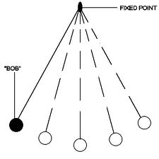
Simple Harmonic Motion
Periodic motion of an object where the force varies directly with the displacement from the equilibrium point.

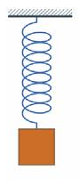
- Examples

- The restoring force is directly proportional to the displacement of the mass from equilibrium.
- For springs:

- For pendulums:

- In a frictionless environment, the motion would continue on indefinitely.
- When friction is present, the motion slows until the object eventually comes to a stop. This is called
Frequency and Period
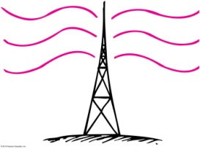
- Frequency
  - Equation
  - Unit
- Period
  - Equation
  - Unit
- Frequency and Period are Inversely Related
- Example:
A swinging pendulum bob completes 4 oscillations every 2 seconds.
  - What is the frequency of the pendulum?
  - What is the period of oscillation?

Period of oscillation for a pendulum.
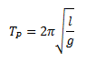

Period of oscillation for an object attached to a spring.
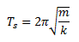

Waves
- What is a wave?
The Two Major Categories of Waves:
- Mechanical Waves
  - Examples
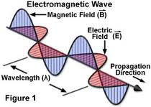
- Electromagnetic Waves
  - Example

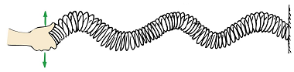
Types of Waves
- Transverse Waves
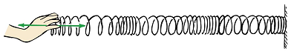
- Longitudinal Waves
- All electromagnetic waves are ________________ and mechanical waves can be ______________ or _______________.

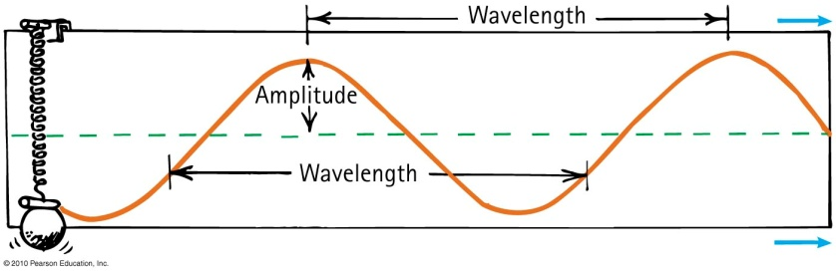
Wave Description
- Transverse Waves
  - Crest
  - Trough
  - Amplitude
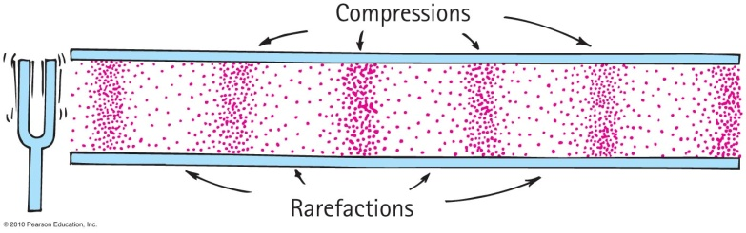
  - Wavelength
- Longitudinal Waves
  - Compression
  - Rarefaction
  - Intensity
  - Wavelength
- Wave Pulses vs. Periodic Waves
  - Wave Pulse
  - Periodic Wave
Properties of Waves
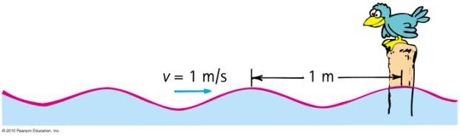
- Wave Motion
- Frequency and Period of Waves
- Wave Speed
  - Equation
  - Examples
1. A person standing in a canyon plays a note from a trumpet with a frequency of 110 Hz. The speed of sound at that spot is 330 m/s.
      - What is the wavelength of the sound wave?
      - The sound wave reflects off of a canyon wall and the person hears the echo 4 seconds after they played it. How far away is the person from the wall?

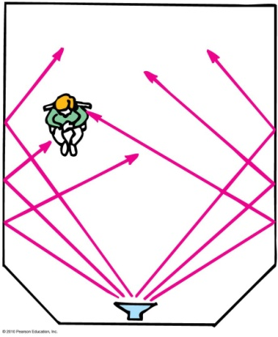
- Reflection
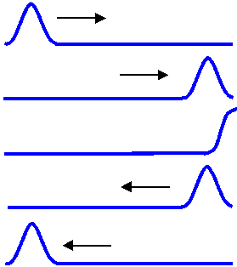
  - Reflection from a free end
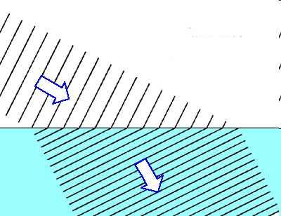
  - Reflection from a fixed end
- Refraction
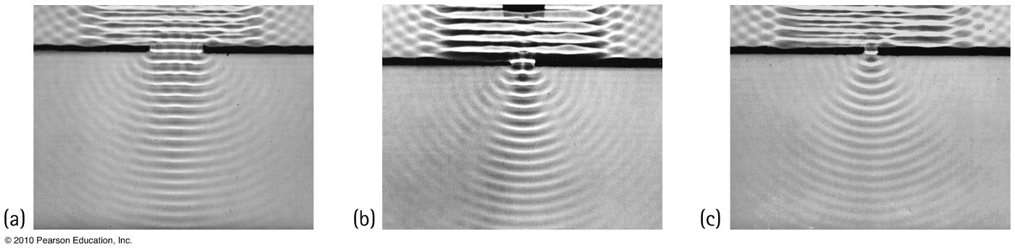
- Diffraction

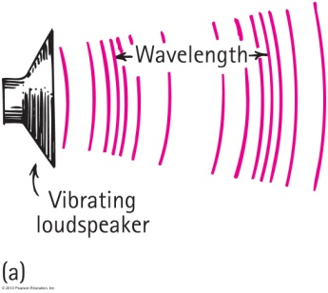
- Properties of Sound Waves
  - Sound in Air

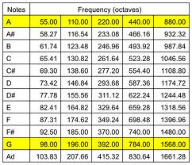
  - Frequency of Sound
    - Infrasonic
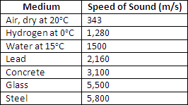
    - Ultrasonic
  - Speed of Sound

- Sound Intensity

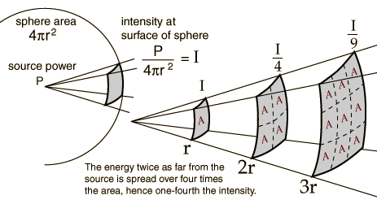

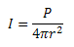
Example:
What is the intensity of the sound waves produced by a trombone at a distance of 3.2 meters when the power output of the trombone is 0.20 Watts?

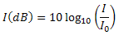
Decibels

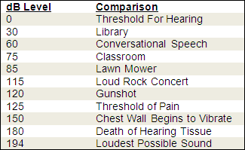

Example:
Suzie finds that the intensity of the sound waves where she is located at a rock concert is 0.316 W/m². What is the decibel level of these sound waves?

Example:
A very loud lawnmower is producing sound waves with a power output of 0.40 Watts. What is the relative intensity (in decibels) of the sound waves 5 meters from the lawnmower?

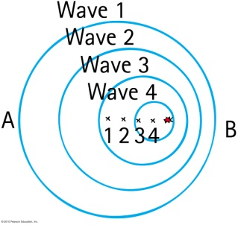

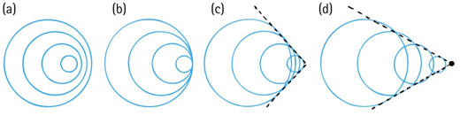
- The Doppler Effect
Shock Wave

Wave Interactions
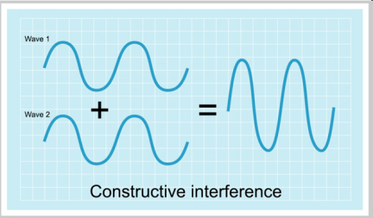
- The Principle of Superposition
- Constructive Interference

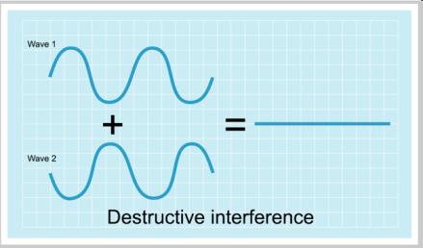
- Destructive Interference
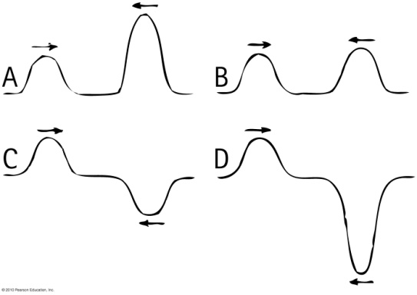
- Example
Shown to the right are four different pairs of wave pulses that move toward and interact with each other. Rank, from most to least, the height of the peak that results when the two pulses coincide.

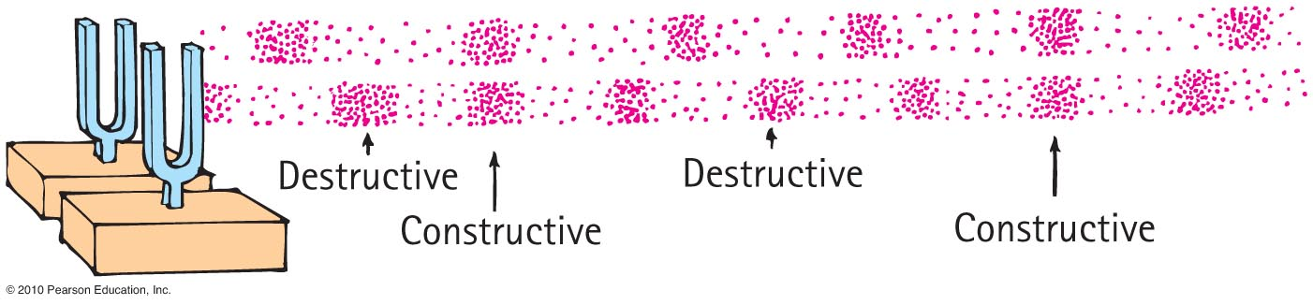
- Interference in Sound Waves

- Standing Waves
A repeated wave that is continuously reflected produces a pattern caused by the rotation of constructive and destructive interference.
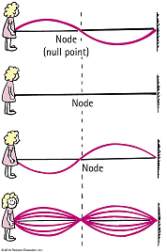
  - Nodes
  - Antinodes
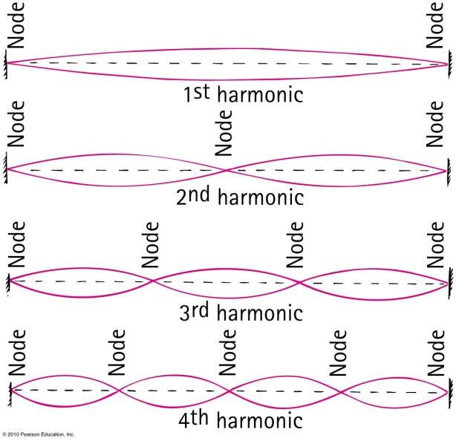
  - Natural (Fundamental) Frequency
  - Harmonics

Example:
A musician plucks a guitar string and it begins to vibrate. The string has a total length of 0.75 meters.
- What is the wavelength of the first harmonic?
- What is the wavelength of the third harmonic?
- What is the frequency of the sixth harmonic if the
speed of the waves is 338 m/s?

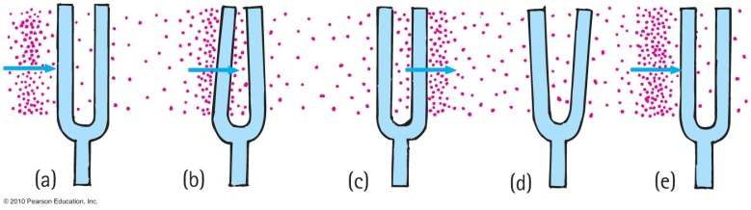
Wave Phenomena
- Resonance

Resonance Tubes
- If air moves quickly across the opening of a tube, a sound is produced.
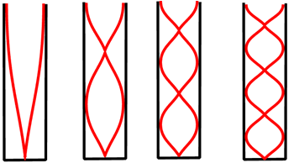
- The air begins to resonate in the tube,
forming a standing wave.
- These standing waves can have harmonics
and can occur in tubes with one open end
or with two open ends.
- The opening of a tube will always contain
an antinode and a barrier will always
contain a node.

Example
Connor blows air across the opening of a 15 cm bottle and it makes a sound at its fundamental frequency.
- What is the wavelength of the sound wave produced in the bottle?
- What is the fundamental frequency? The speed of sound in the air inside the bottle is 337 m/s.
Answers: 0.6m, 562 Hz

An organ pipe is 2.5 meters long and is open on both ends. The speed of sound in the air around and inside the pipe is 341 m/s.
- What is the fundamental frequency of a sound wave produced in this pipe?
- What is the wavelength of the 3rd harmonic?
- What is the frequency of the 6th harmonic?
Answers: 68.2 Hz, 1.67 meters, 409.2 Hz

