**Physics Unit 8 Light and Optics Note Outline**

**8.1 Properties of Light**

Seven Properties of light

* Light Travels Fast
* Light Has a Dual Nature
* Light Travels in Straight Lines
* How do shadows form?
* Shadows vary
* Light Varies in Intensity
* Light interacts with matter
* Light is comprised of many colors
* What kind of light can we see?

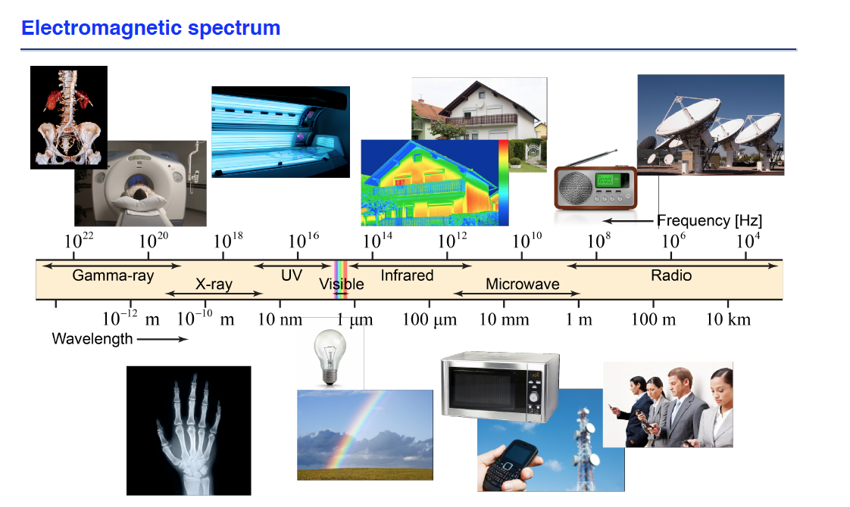

* Light carries energy and information

**8.2 Optical Devices**

* 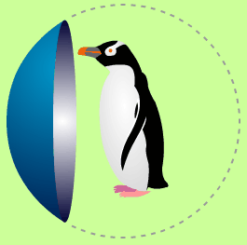Mirrors

Spherical Mirrors 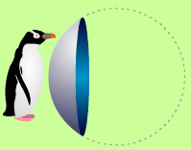 



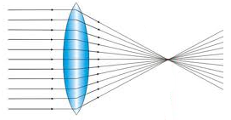Lens

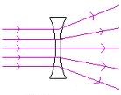

Application: The Eye

The lens forms a real image on the retina

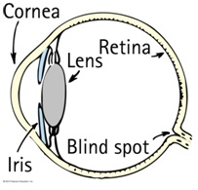Myopia (near sidedness) – the image forms in front of the retina

Hyperopic (far-sidedness) – the image forms behind the retina

* Prism
* Reflection
* 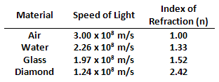Refraction

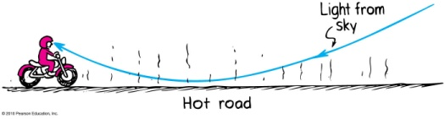

* 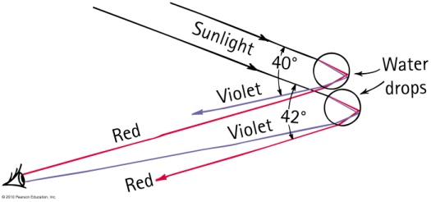Examples of Refraction
* The magnifying glass

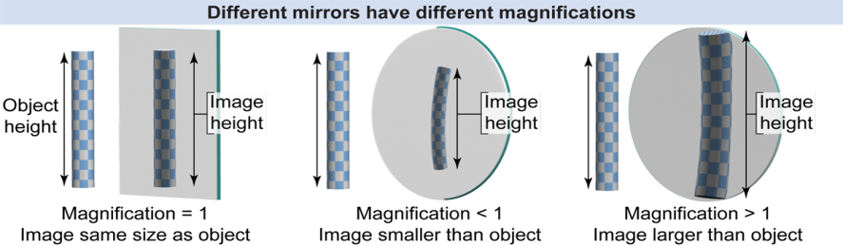

* Objects and Image Heights
* What do magnification values mean?
* Light passing through medium
* Transparent
* Opaque
* Translucent

**8.3 Reflection**

* 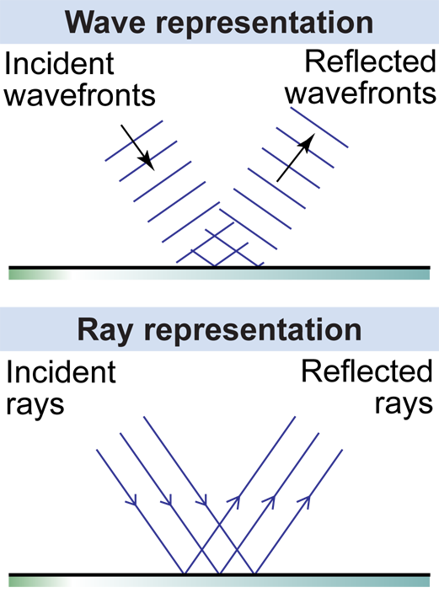Ray representation of light
* Ray Diagrams

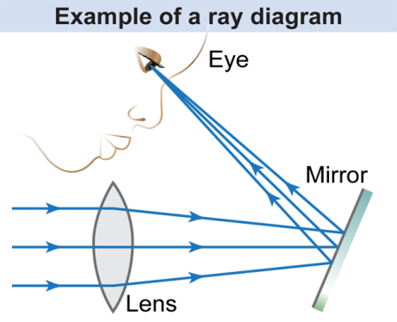

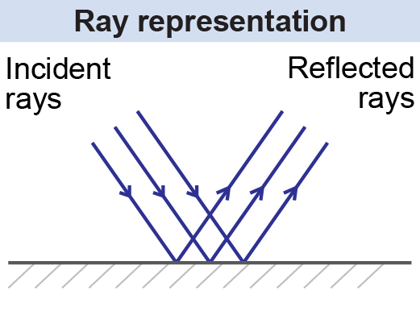

* Incident and Reflected Rays

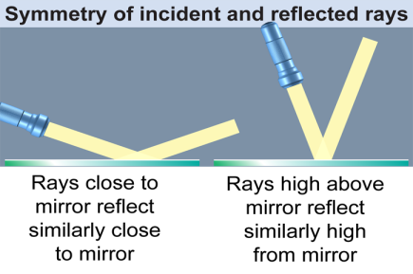

* Symmetry

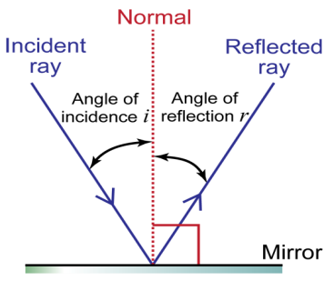

* Angle of Incidence and Reflection



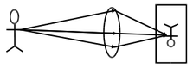**8.4 Images**

* What is an image?

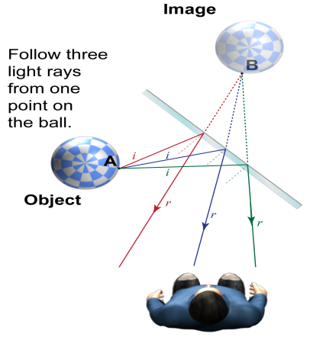

* Image formation for a flat mirror

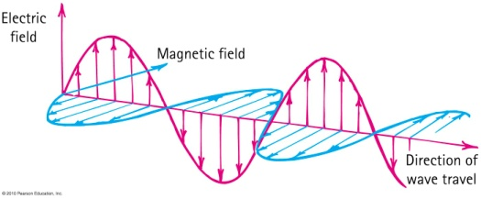

**8.5 Light Color and Frequency**

* What is light?
* What is an electromagnetic wave?
* Light waves vs. Sound waves
* **Speed of Light**



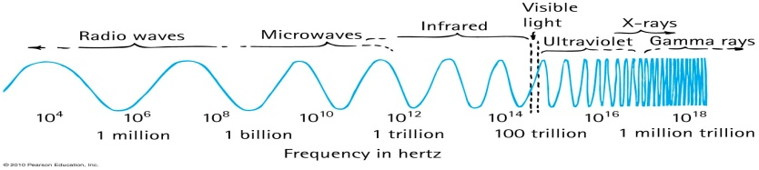

* The EM Spectrum
* Wave Particle Duality of Light
* Frequency and Color

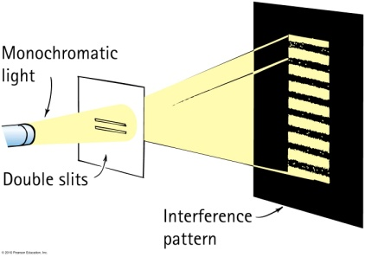

* Light as Waves

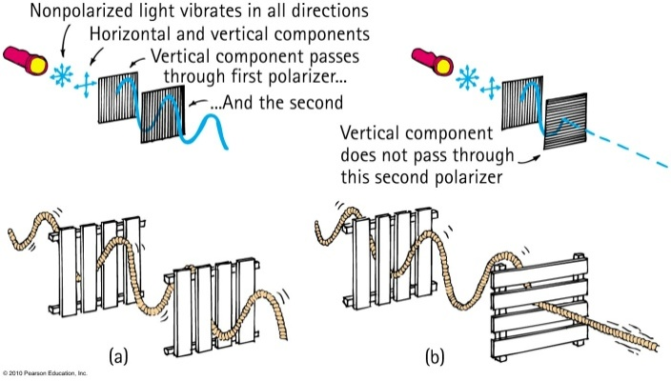

* Polarization