Physics Unit 11: Electricity – Note Outline
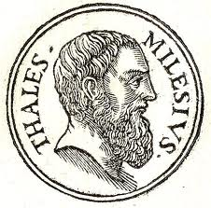
Part 1: Electrostatics
- “Electricity”
- “Electrostatics”
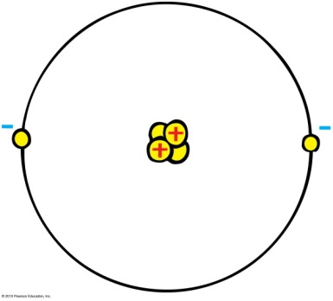
- What is Charge?
  - Positive Charge
  - Negative Charge
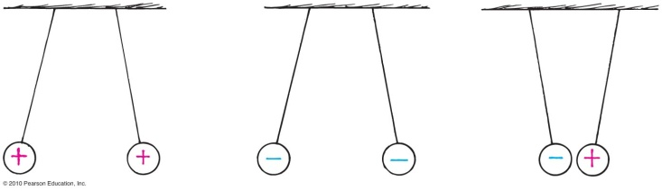
  - Electric Force
  - SI Unit for Charge
  - Charge of electron and proton
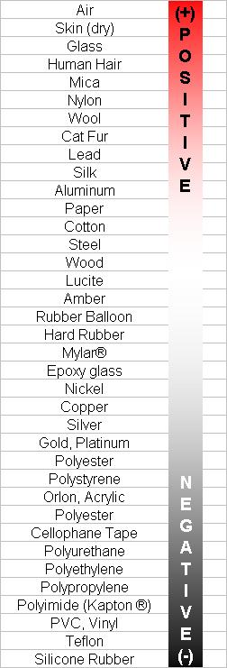
- Giving Objects a Charge
  - Charging with Friction – two materials are rubbed together and exchange electrons
    - The Triboelectric Series
  - Charging by Contact - A charged object touches another object
  - Charging by Induction – charging an object without touching
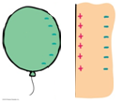
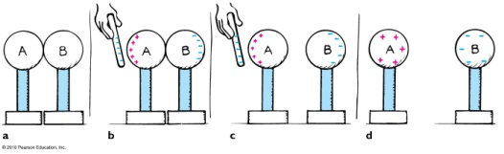
    - Charge Polarization
- Conductors and Insulators – Not all materials act the same!
  - Conductors – allow electric charges to flow through them easily
Examples:
  - Insulators – resist the flow of electric charge
Examples:
  - Semiconductors – have properties of both conductors and insulators
Examples:
- Conservation of Charge
The net charge of a system will always remain constant.
  - Examples
    - An atom has 10 protons and 12 electrons. What is the net charge on the atom?
    - An atom has 6 protons and 2 electrons. What is the net charge on the atom?
    - Charges are placed on two identical metal spheres. The charge on one sphere is -6 and the charge on the other sphere is 0. If the two spheres are touched together, what will be the resulting charge on each?
    - Now the spheres have a charge of +2 and -4. What will be the resulting charge after touching?
- Electric Force
  - Coulomb’s Law
Describes the amount of electric force between two charges separated by a distance.
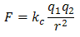
  - Examples
    - A +1.0 µC charge is placed 0.1 m from a -1.0 µC charge.
      - How much electric force exists between the charges?
      - Is the force attractive or repulsive?
    - A proton and an electron are placed 1.0 x 10⁻⁶ meters from one another. Calculate the magnitude of the electric force between the particles.
    - A pencil is given a charge of +8 μC and is placed 50 cm from a cup that has an unknown charge. The magnitude of the attractive electrical force between the cup and pencil is 3.2 Newtons. What is the magnitude and sign of the charge on the cup?
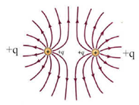
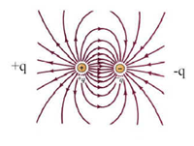
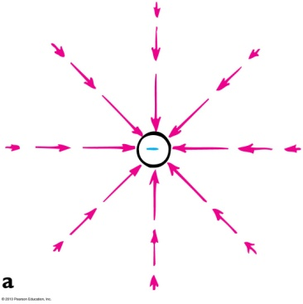
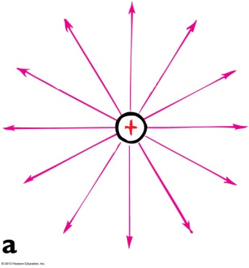
- Electric Fields
The region around a charge in which it can exert a force on other charges.
  - Force on a charge in an electric field
    - Equation
    - Examples
      - A charge of +6.5 μC is placed in an electric field that has a magnitude of 2.3x10⁵ N/C. What is the magnitude of the force exerted on this charge?
      - A -9μC charge is placed in an electric field of 1.5x10⁵ N/C. How much force is felt by the charge?
      - What must the strength of an electric field be in order to exert a force of
6.0 x 10⁻⁵ Newtons on a proton?
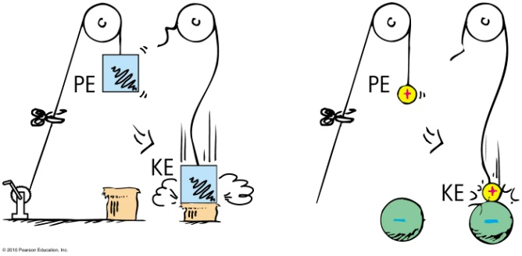
- Electric Potential
Part 2: Electric Circuits
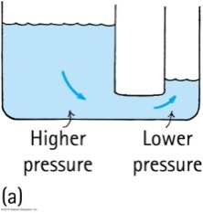
- Why do charges move?
- Potential Difference
The ends of a conductor are at a different electrical potential.
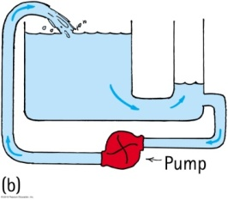
  - Volts
  - Voltage Sources
- Electric Current
The rate at which charges flow through a conductor
  - Amperes
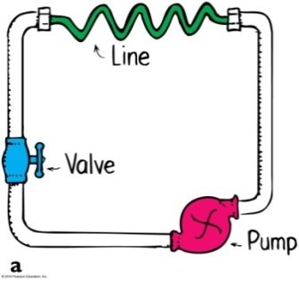
- Electrical Resistance –
the “difficulty” charges face as they move through a circuit
  - What determines the resistance of a conductor?
    - Resistivity of the material
    - Length
    - Cross-sectional area
    - Temperature
  - Ohms
- Circuit Diagrams
  - Requirements of Circuits

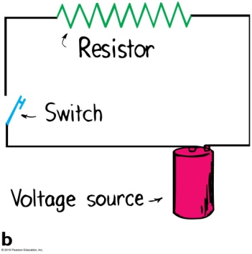
  - Circuit Diagram Symbols
  - Simple Circuits
- Ohm’s Law
The amount of electrical current in a circuit is directly proportional to the voltage and indirectly proportional to the resistance.
  - Equation
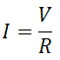
  - Examples
  - A light bulb has a resistance of 30Ω. What voltage would be required to run 4 Amperes of current through the bulb?
  - What amount of current would be used if a 10Ω resistor was connected to a 240 V circuit?
- Electric Power
The rate at which energy gets used by a component in a circuit.
  - Equation:

  - Examples:
    - How much power is dissipated in a toaster if it is connected to a 120-Volt circuit and uses 8 Amps?
    - A light bulb has a power rating of 60-Watts. How much current would flow through it if it was connected to a circuit with 12 Volts?
- Capacitors and Capacitance
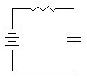
  - What is a capacitor?
  - Capacitance
  - Equation
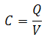
  - Examples
    - What is the capacitance of a capacitor that is connected in a 12-Volt circuit and holds a charge of 6.0 x 10⁻⁵ Coulombs?
    - How much charge can a 150 µF capacitor hold if it is connected to a potential difference of 120 Volts?

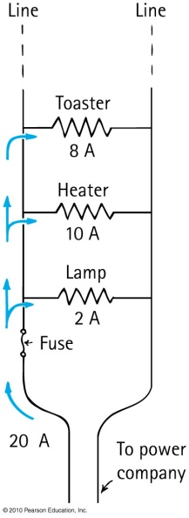
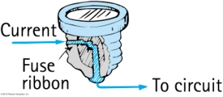
- Applications in Household Circuits
  - Fuses and circuit breakers
  - Electrical Energy
    - Review: Power is the rate at which energy is used $Power=\frac{Energy}{Time}$
    - Electric companies measure energy consumed in kilowatt-hours.
      - A kW-hr is the energy delivered in one hour
    - Cost = (amount of energy) x (price rate)
    - Example
How much does it cost to operate a 100 W (0.1 kW) light bulb for 24h at a price of
$0.08 per kW-h?
  - AC vs. DC Current
    - Direct Current – charges move one direction
    - Alternating Current – charges change direction rapidly
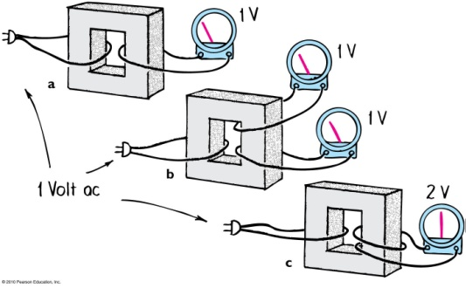
  - Transformers
“transform” voltage in power lines
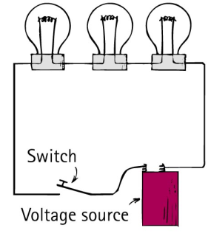
- Series Circuits
  - Characteristics of Series Circuits
  - Electric current has only one pathway, so the current moving through each device is numerically equal.
  - The current is resisted by each device as it moves through the circuit. The total resistance is the sum of the individual resistances along the circuit path.
  - The total current in the circuit is equal to the total voltage of the circuit divided by the total resistance of the circuit, in accordance with Ohm’s law.
  - The supply (total) voltage of the circuit equals the sum of the individual voltage drops across each device.
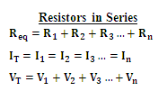
  - The voltage drop across each device is proportional to its resistance – Ohm’s Law applies separately to each device.
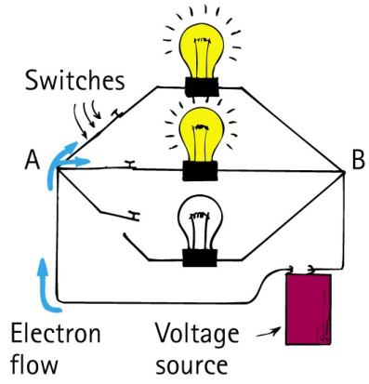
- Parallel Circuits

  - Characteristics of Parallel Circuits
  - Each “branch” connects the same two points coming in and out of the power source. The voltage is therefore the same across each branch.
  - The current divides among the parallel branches. Ohm’s law applies separately to each branch.
  - The total current in the circuit equals the sum of the currents in its parallel branches. This sum equals the current in the battery or other voltage source.
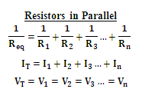
  - As the number of parallel branches is increased, the overall resistance of the circuit is decreased. This means that the overall resistance of the circuit is less than the resistance of any one of the branches.

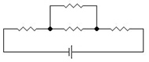
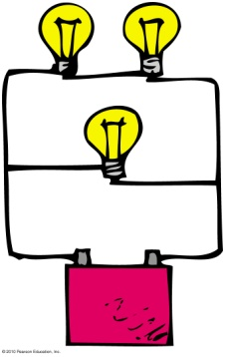
- Complex Circuits
- Sample Circuit Diagram Problems
- Three resistors are set up in series and connected to a 12-Volt power supply, as in the diagram. R₁ = 10Ω, R₂ = 5Ω, and R₃ = 15Ω
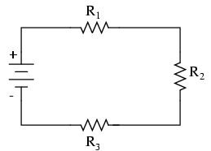
  - What is the total equivalent resistance of this circuit?
  - The current running through R₁, R₂, and R₃ is all 0.4 Amps. What is the total current of the circuit?
  - What is the voltage drop across R₁?
- Three resistors are connected in parallel with a 30-Volt power supply, as in the diagram.
R₁ = 30Ω, R₂ = 60Ω, and R₃ = 60Ω
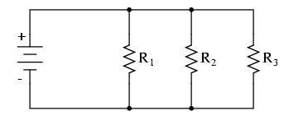
  - What is the equivalent resistance of the whole circuit?
  - What is the voltage across R₁, R₂, and R₃?
  - What is the current through R₂?
- Complete the table of values for each circuit below.
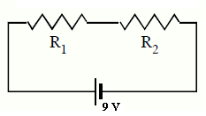

 | V | I | R
Total | 9 V
R₁ |  |  | 1 Ω
R₂ |  |  | 2 Ω

 | V | I | R
Total | 12 V
R₁ |  |  | 6 Ω
R₂ |  |  | 12 Ω
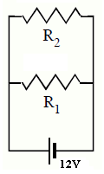

 | V | I | R | P
Total
R₁ | 54 V
R₂ |  |  | 12 Ω
R₃ | 30 V |  | 10 Ω
R₄ |  |  | 20 Ω
 | V | I | R
Total
R₁ |  |  | 6 Ω
R₂ |  | 2 A | 12 Ω
R₃ |  | 2 A
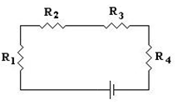

 | V | I | R
Total | 12 V
R₁ | 3 V |  | 1.5 Ω
R₂
R₃ |  |  | 12 Ω
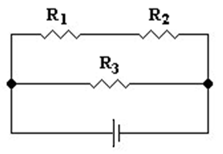
 | V | I | R
Total
R₁ |  | 4 A | 12 Ω
R₂ |  |  | 24 Ω
R₃ | 24 V
